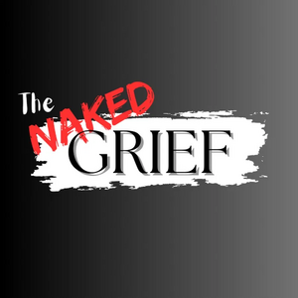 | REAL EXTENDED AFTERCARE  The Naked Grief · Camden, Delaware

REACH Charter Partner Pricing
Introductory Charter Rate · Locked for Life
REACH · Real Extended Aftercare for Community Healing
SECTION 01 · THE CHARTER RATE

The REACH Charter Rate
$499 PER 45-DAY CYCLE | 🔒  LOCKED-IN FOR LIFE
Introductory rate for Charter Partners only. Locked-in for the life of the partnership. Public rate moves to $999 on January 1st.
EACH CYCLE INCLUDES
30 Arrangement Folder Inserts  High-quality grayscale | 300 REACH Care Cards  Plain Naked Grief care cards
Unlimited Digital Access  For families | Personalized Partner Portal  Real-time scan tracking
REACH Template Library  12 weeks of dripped content | Bi-Weekly Partner Support Calls  Direct guidance from Karen

SECTION 02 · OPTIONAL ADD-ON

The Bracing 13 Workbook
“A 13-month, 313-page physical companion for the healing journey.”
OPTION A · RETAIL | OPTION B · PARTNER RATE
Amazon Marketplace  Direct partner bulk order available below. | Direct Partner Bulk Order
PRICE $64.95  per workbook · retail | PRICE $56.50  per workbook · 13% discount
BEST FOR  Immediate individual family needs. | SAVINGS  Professional partner rate.  Please allow 14–20 days for delivery. Direct orders are processed through the Partner Portal.

TERMS & CONDITIONS
▪ Each cycle lasts 45 days.
▪ Additional cards or inserts can be ordered via the Portal.
▪ Charter rate remains valid as long as partnership is active.
The Naked Grief, LLC · info@thenakedgrief.com · Camden, Delaware
CHARTER PARTNERS ONLY

